**COMPUTER PROGRAMING 1 GROUP ASSIGNMENT.**

UNIVERSITY: JKUAT

LECTURER: Mr. PAUL BETT

COURSE: 2.2 EEE B2

DUE DATE: 06/02/2023

GROUP MEMBERS: SIMON MWITA ENE211-0046/2021

LUCKY RAI ENE211-0054/2021

AIM AKINYI ENE211-0024/2021

RACHEAL MAINA ENE211-0280/2021

1.

Tc=(T-32)/9*5

*Output* Tc

*Input* T

2.

. 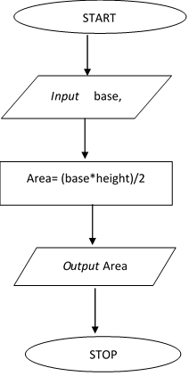

3.

*Input*

marks

marks= marks + x

Avg = marks / N

Is

N=10?

*Output*

*Avg*

N=N+1

N=1, x=0

*Input*

x